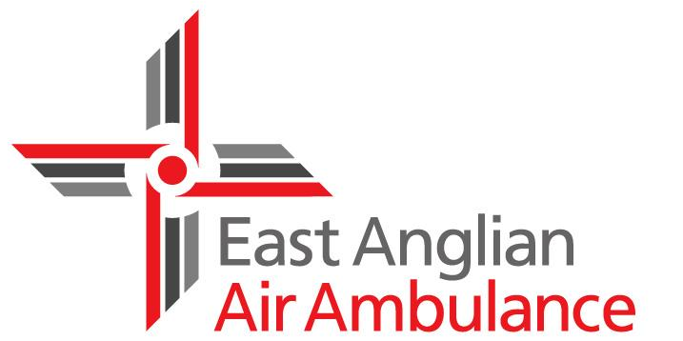

Volunteer Role Profile

Events Volunteer

About East Anglian Air Ambulance
We are a 365 day-a-year lifesaving service working across Bedfordshire, Cambridgeshire, Norfolk and Suffolk. Since the charity’s launch in 2000, the dedicated, highly skilled medical crews on our specially equipped helicopters have helped to save the lives of hundreds of people unfortunate enough to be involved in accidents or medical emergencies in this region.

About this role
We are regularly invited to attend events across the county which provides a great opportunity to promote the work of our charity. We go to fetes, fairs and country shows, as well as carnivals and sporting events. We take the chance to share information about the work we do and also sell our merchandise, helping us to raise vital funds. If you like getting out and about and meeting people, this is the role for you.

What will I be doing?
• Working with the local fundraising team, attending events and providing ‘hands on’ help
• Assisting in the setting up and packing up of the event equipment
• Speaking to the public about the work of the charity

When can I volunteer?

• Events are held across the county throughout the year, although the summer months are busier, so there’s bound to be one near you and the hours are flexible too.

What we are looking for

• Excellent interpersonal, communication and teamwork skills

• A friendly, approachable and enthusiastic manner

• A willingness to collaborate and work with other fundraising team members

• Ability and confidence to handle money

What we can offer

• The chance to make a real difference in your local community

• Meet new people in your area

• Join a warm and friendly team of like-minded people

• Travel expenses are paid

• Full training and ongoing support is provided

Interested?

For further information please call 03450 669 999 and ask to speak to someone from the volunteers team or email volunteer@eaaa.org.uk and someone will get back to you.

