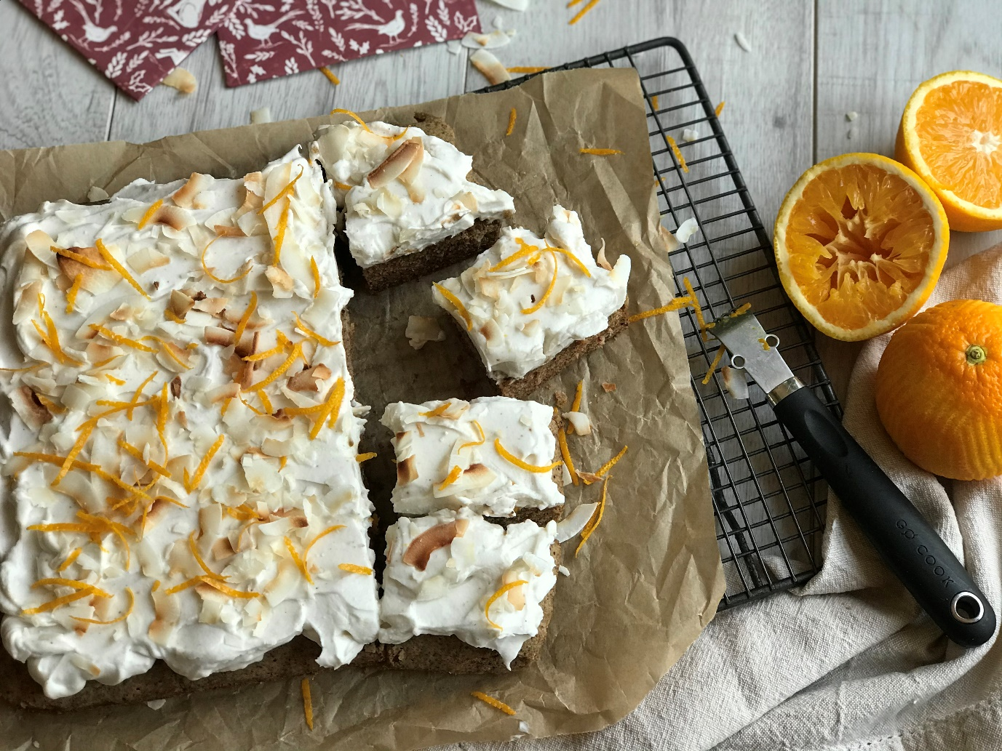

Chia Spiced Cake with Orange coconut frosting.
This cake can be made in advance and frosted before serving or if you leave off the frosting its delicious served warm with a dollop of plant-based ice-cream or custard. This cake freezes well without the frosting, just defrost at room temperature.
Ingredients
250g gluten free plain flour
200g unrefined sugar, I used coconut sugar, but soft brown sugar works too.
3 tsp chai spice *- see recipe for your homemade spice mix below.
1 tsp bicarbonate of soda
Pinch salt
240 ml unsweetened almond milk
60 ml rapeseed oil
1 tsp vanilla extract
Frosting
2x cans full fat coconut milk (left in fridge for at least 24 hours to separate the water from the cream)
1 tbsp freshly squeezed orange juice
2 tsp maple syrup
2 tsp orange zest toasted coconut shavings to decorate.

Method
Pre-heat the oven to 180oc and line with parchment a square cake tin.
In a large bowl add the flour, sugar, spices bicarbonate of soda, salt and mix. In a jug combine the milk, oil, vanilla extract. Add wet to dry to combine the pour into your cake tin, bake for 30-35 minutes until a skewer comes out clean when inserted. This mixture is quite a wet runny mix. One the cake is cooked remove from the oven and allow to cool in the cake tin.
Frosting
In the bowl of a food mixer, (or with a handheld mixer) add the cream( this is the solid fat of the coconut milk) from the cans of coconut milk, add the rest of the frosting ingredients apart from the coconut shavings and mix until firm like whipped cream. Spread this mixture over your cooled cake and decorate with orange zest and toasted coconut.
*Homemade Chai Spice- Mix ingredients together and store in a jar.
1 tsp ground cardamom
1 tsp ground cloves
3tsp ground ginger
2 tsp ground cinnamon
1 tsp allspice
¼ tsp ground black pepper.

