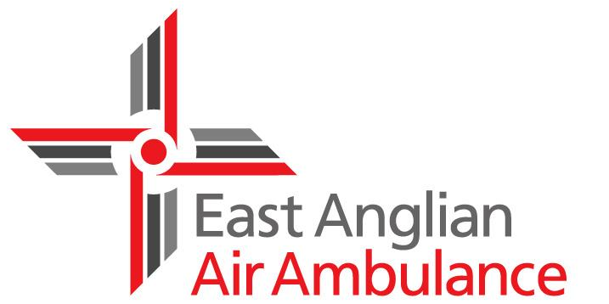
Job Description
Job title: Operations Support Administrator
Reports to: Base Manager

- Main purpose of job
To provide Operational Support to the East Anglian Air Ambulance Clinical, Aviation and Operations Teams whilst also supplying information and statistical support to the charity.
This is a key position, which forms an integral part of the operations department.
- Main duties/responsibilities
- Assist in the completion of the clinical duty rota, by liaising with, doctors and paramedics as required or directed by the duties coordinator. (NB: frequent rota changes are required often at short notice). This includes clinical supervision for both doctors and CCP’s, factoring in monthly D&D sessions, CGD days for trainees.
- Control and monitor the consultants and Operations Team Duty on Call rotas, and ensure documents are produced monthly for payroll.
- Liaise with the HR team to ensure all clinical staff records are controlled and monitored, in relation to New Joiners, Leavers, qualifications and training records.
- Plan Fellow/PHEM inductions for any new starters joining the clinical team.
- Circulate new systems and documents to clinical staff via Team Reads and Standard Operating Procedures (SOPs).
- Maintain daily contact with both clinical bases (Norwich and Cambridge) Monitor and maintain a programme that ensures daily, weekly, monthly, annual Audits and Checks are carried out in a timely responsible fashion. Producing monthly compliance reports which will provide evidence for CQC purposes.
- Provide support both in advance of, and during, monthly Clinical Governance Days. This also involves booking the venue and catering. Organising a rota for the clinical team to lead on the day, this involving a PHEM trainee with the support from a CCP and consultant/senior clinician. Also consulting the aircraft operators to ensure both aircrafts can attend each time.
- Be able to present the evidence when required during CQC visits which may be planned or spontaneous.
- Order, receive, record and issue Personal Protective Equipment, Medical equipment, consumables and drugs for both Norwich and Cambridge (including holding records of destruction of unused controlled drugs).
- Ensure the records concerning Electrical Medical Equipment (EME) used within the clinical teams is correctly maintained identifying expiry dates for warranties and servicing. Be able to take the appropriate action with issues found in an expeditious manner.
- Provide general Administrative assistance to the Director of Operations, Aviation Consultant, Medical Director, Operations and clinical staff as required.
- There may be occasions when the post holder will be required to work at different locations and outside normal working hours.
- Plan the Regional PHEM Courses for new doctors/paramedics alongside MAGPAS
- Manage the clinical e-learning, ensuring all clinicians have undertaken the appropriate training required.
- Minute monthly meetings and distribute to the Operations team. Also being available to minute any other meeting which may arise.
- Organise and help facilitate if required any training sessions such as yearly CRM, new equipment sign offs, etc.
- General duties/responsibilities
- From time to time, the post holder may be required to work at any of the Charity’s sites in line with organisational needs.
- All staff must ensure confidentiality and security of information dealt with in the course of performing their duties. They must comply with and keep up to date with Charity policies and legislation on confidentiality, data protection, freedom of information and computer misuse.
- All staff are required to adhere to and act consistently with all relevant health and safety legislation and Charity policies and procedures in order to ensure that their own and the health, safety and security of others is maintained.
- Staff will actively promote the Charity’s commitment to equality and diversity by treating everyone with dignity and respect.
- All employees should take a proactive approach to personal development in order to ensure that skillsets are aligned to the demands of the role as it evolves and develops to meet the organisation’s changing needs.
- All employees have a responsibility for protecting, safeguarding and promoting the welfare of children and vulnerable adults.
- It is the responsibility of all employees to conduct all business in an honest and ethical manner.
- Staff should uphold and demonstrate the Charity’s values (community, passion, accountability, innovation, quality).
- All staff should be aware of their responsibilities to protect the reputation of the charity e.g. social media and behaviour.
- Reporting incidents via the Datix system as part of an open and fair culture.
- Staff should be willing to undertake any activity as deemed appropriate by the charity that is in line with skills, experience and knowledge.

- Person specification
Education and qualifications
Essential | Desirable
- Key Skill Level 2: 5 GCSEs at Grade C or above; NVQ level 2; or equivalent. | Key Skill Level 3: 2 ‘A’ levels (4 AS Levels), ONC, OND, BTEC, NVQ level 3 or equivalent.
Experience
Essential | Desirable
Previous experience in a dynamically changing environment. | Understanding SOPs
Experienced in all Microsoft Office products: Microsoft Word, excel, outlook, PowerPoint. | An awareness of the charity
Must be able to create and use spreadsheets to a high standard to create data for both internal and external reporting | An appreciation of Clinical Governance
Knowledge and skills
Essential | Desirable
Confident communicator (both written and oral) | Resilience and good sense of humour
Full UK Driving licence and transport.
Flexible and adaptable approach due to the nature of the position.
The ability to multi task and prioritise.
The ability as a non-clinician to form a good working relationship and understanding with clinicians.
Possess strong people skills, and be able to interact with colleagues and partners at different levels.
Personal qualities
Essential | Desirable
Self starter, with positive and proactive approach
Good multi tasker who works well under pressure in busy environment
Thorough and meticulous with excellent attention to detail

