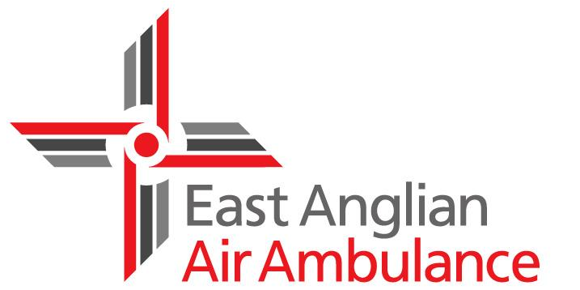

Volunteer Role Profile

Volunteer Speaker

About East Anglian Air Ambulance
We are a 365 day-a-year lifesaving service working across Bedfordshire, Cambridgeshire, Norfolk and Suffolk. Since the charity’s launch in 2000, the dedicated, highly skilled medical crews on our specially equipped helicopters have helped to save the lives of hundreds of people unfortunate enough to be involved in accidents or medical emergencies in this region.

About this role
We are often asked to attend community events to present information to groups of people who are interested in the work of East Anglian Air Ambulance. We need volunteers who enjoy speaking in public, are able to communicate clearly and who can inspire and motivate people to become volunteers themselves. This work is invaluable in ‘spreading the word’ about what we do and how people can get involved

What will I be doing?
• Delivering prepared talks of around 30 minutes to a variety of different audiences. PowerPoint slides, a projector and screen are provided if you wish to use them
• Responding flexibly and creatively to different groups needs and expectations
• Informing people of all the ways they can get involved and support us through volunteering and fundraising

When can I volunteer?

• The requests for talks vary and can sometimes be in the evenings

What we are looking for

• Excellent interpersonal, motivational and communication skills

• Experience in public speaking and own transport would be beneficial

• A friendly, approachable and enthusiastic manner

• A flexible, independent and creative approach

• Willingness to learn more about our work and deliver our key messages

What we can offer

• The opportunity to build your communication skills

• Meet new people in your area and give back to your local community

• Travel expenses are paid

• Full training and ongoing support is provided, including the opportunity to shadow existing speakers to gain experience and confidence
Interested?

For further information please call 03450 669 999 and ask to speak to someone from the volunteers team or email volunteer@eaaa.org.uk and someone will get back to you.

