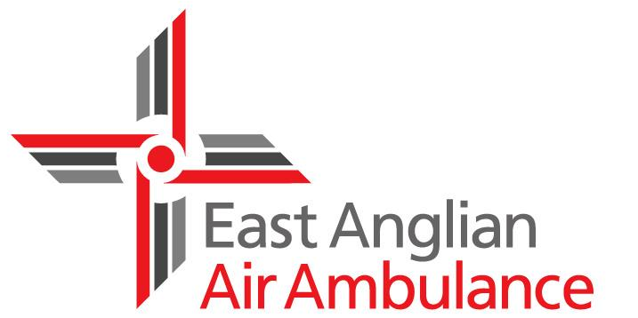

Volunteer Role Profile

Store Collectors and Town Collections

About East Anglian Air Ambulance
We are a 365 day-a-year lifesaving service working across Bedfordshire, Cambridgeshire, Norfolk and Suffolk. Since the charity’s launch in 2000, the dedicated, highly skilled medical crews on our specially equipped helicopters have helped to save the lives of hundreds of people unfortunate enough to be involved in accidents or medical emergencies in this region.

About this role
Collections are a very simple way to raise valuable funds and a couple of hours of your time can make a big difference, collecting for one day alone can raise £500. All you have to do is stand with a bucket, smile and watch the coins come your way! It’s a great opportunity to meet lots of new people, including other volunteers, and to help us raise vital funds.

What will I be doing?
•Collecting at supermarkets, shopping centres and on the street
•Giving out leaflets for upcoming East Anglian Air Ambulance events
•Speaking to the public about the work of the charity

When can I volunteer?

Collections are held across the county throughout the year, so there’s bound to be one near you and the hours are flexible too.

What we are looking for

• Excellent interpersonal, communication and teamwork skills

• A friendly, approachable and enthusiastic manner

• A willingness to collaborate and work with other fundraising team members

What we can offer

• The chance to make a real difference in your local community

• Meet new people in your area

• Join a warm and friendly team of likeminded people

• Travel expenses are paid

• Full training and ongoing support is provided

Interested?

For further information please contact our volunteer team either by phone on 03450 669 999 or by email to volunteer@eaaa.org.uk

