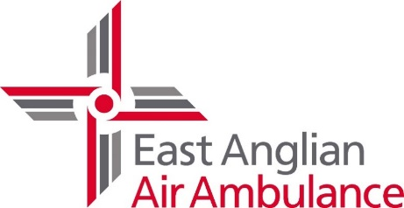
CPR/Defib training booking form

Details provided with this booking form may be shared with our CPR volunteers for training purposes.
*Must be completed
Event/Group Name *
Booking contact name *
Email *
Telephone number *
Full training venue address (including County & Postcode) *
Will the group consist of Adults/Children *
(If children, what ages?)
(All CPR volunteers have an Enhanced DBS without barring. Therefore, volunteers will still require supervision when delivering training to children and vulnerable adults)
Number of participants *
Information on room size/floor surface (We need adequate space to perform training, table, chairs to one side etc)
Is there parking on site?
(Is it free?) We do need to drop off kit near to the entrance
Does the group have a connection to EAAA? (ie is one of your members a patient)
How did you hear about the training?
Please provide us with a minimum of 6 x potential dates/timings for the session(s) to be held, with a maximum of 2 x sessions in any one month*

How would you like to be contacted? (email/phone/post/SMS)
Additional information

