How to present the Community EAAA stand with the new equipment
The new plinths on the stand are to create a bit of a journey, to educate the public and to encourage conversations. Please follow the below steps to set up the stand in the correct way.
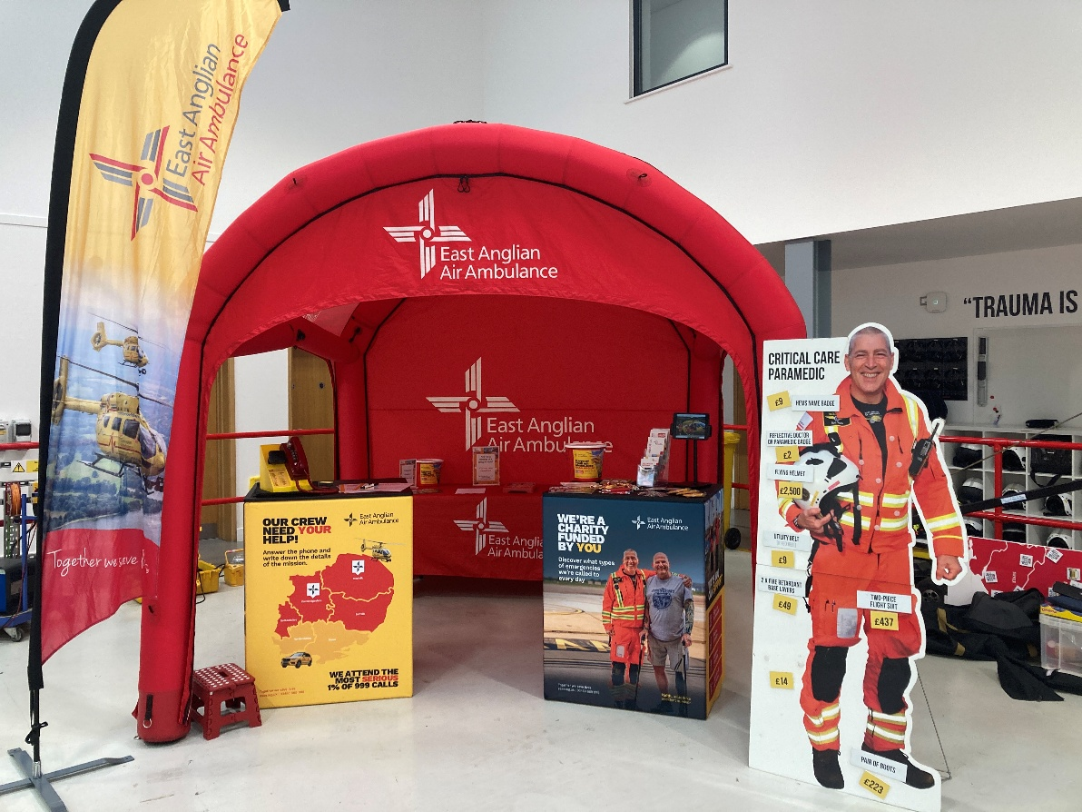

- Set up the gazebo
- Set up the two plinths, leaving a gap between the two so public can walk to the back of the gazebo for the other activity.
- One plinth needs to have the Red phone on, but it needs to be the one with the below design on as it’s relevant to the phone. There is a battery pack to operate the Red Phone, push the button and it will show some lights, push it one more and you will see a green light to indicate this is on, when not in use you can turn off the battery pack by holding the button down but also to save power, once on, push the button once again and it will go into power save mode and last longer. There are sheets that are wipeable for the public/kids to use to capture the information given from the call on the phone. There is a phonic alphabet to help the children understand the grid reference given. There is a red step for the smaller children to use to reach the phone and tabletop, place this by the plinth. (see below picture)
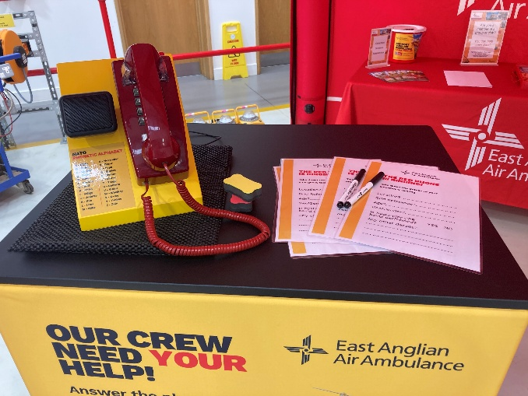
- The other plinth has the iPad on. Place the iPad into the iPad stand, turn on, the code to unlock is 145001, if you then tap the photo gallery button you will see all the options of what the public can choose to watch, videos, photo’s of various elements of the charity, leave the screen on this area. There is a power pack if the iPad battery runs out. All the various items for donations, the holders with leaflets and some Lift Off can be placed around the top. (see below picture)
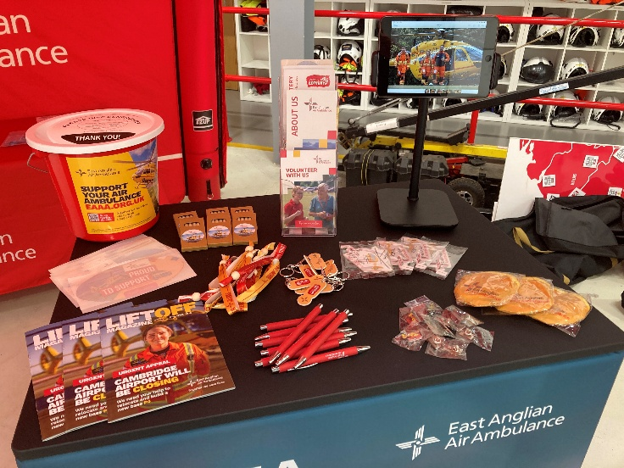

- The table, with a tablecloth on, is to be placed at the back of the gazebo and the operation game, the colouring pages and the make your own helicopter pages are to be set out on here, (this gives a good working space for the children to do the activity) (see below picture)
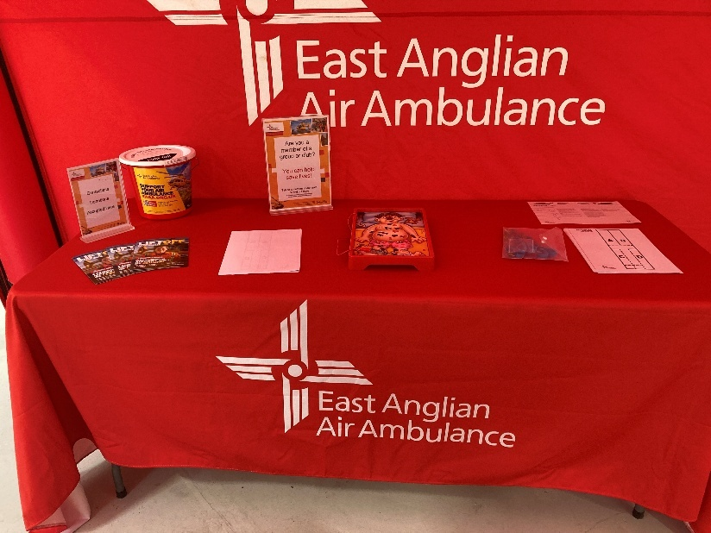

- The children’s fancy dress stand and fancy-dress items can be placed inside the gazebo on the right-hand side or where there is space. (this is to follow soon)
- The Crew kit board is to be placed beside the righthand side of the gazebo (so right when looking at gazebo) this is to allow space for the phone activity on the left-hand side. Attach the legs to the back of the crew board so it tilts backwards a little bit. The aim of this board is to get the public to guess how much things cost, so the prices are left off when setting up and are kept in a small plastic box. The prices of the kit are on a picture on the back of the crew board so you can check if they have got it right. This is all part of the education aspect of the stand, so placing the prices on first defeats the object. (see below picture) new crew boards will arriving soon
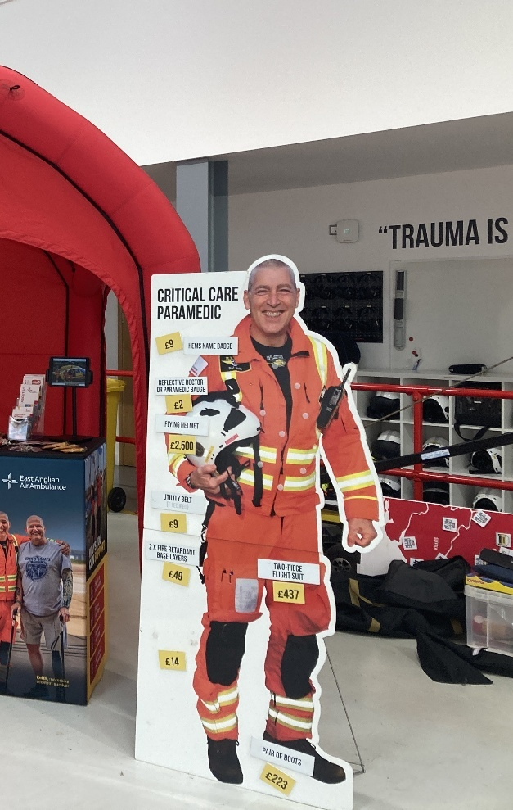

- Place the flag sail to the left of the gazebo (left when looking at the gazebo)
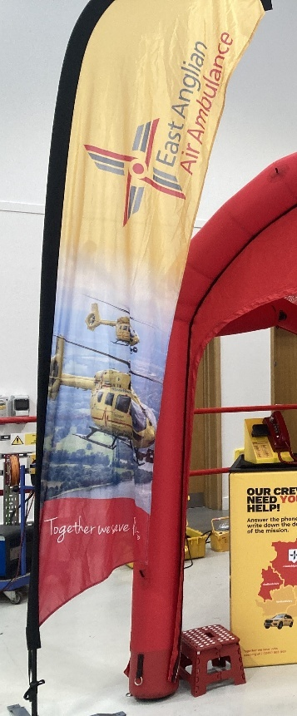
Now we have a wonderful looking stand, ready to educate the public on all things EAAA

